Define a complete project in terms of Models included. Later, unneeded models can be removed.

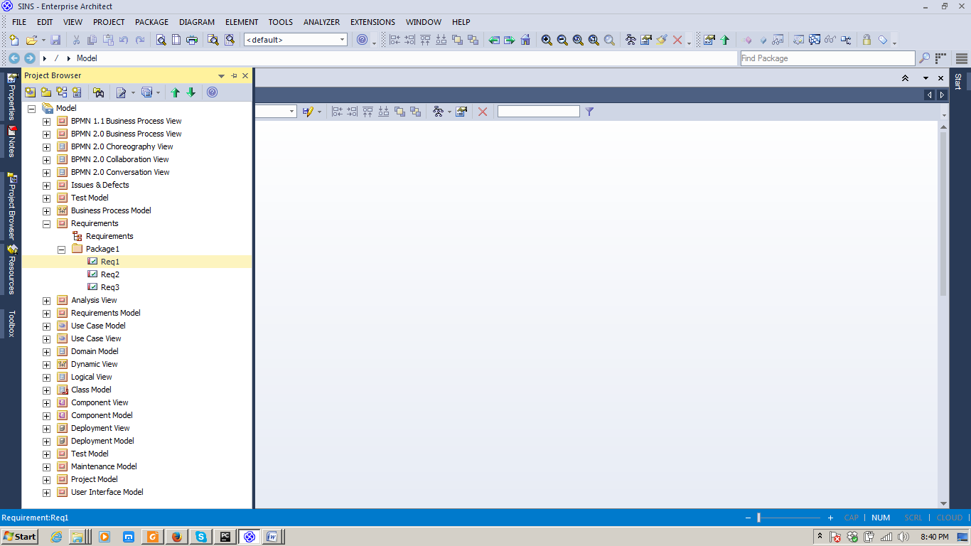

Adopt Perspective

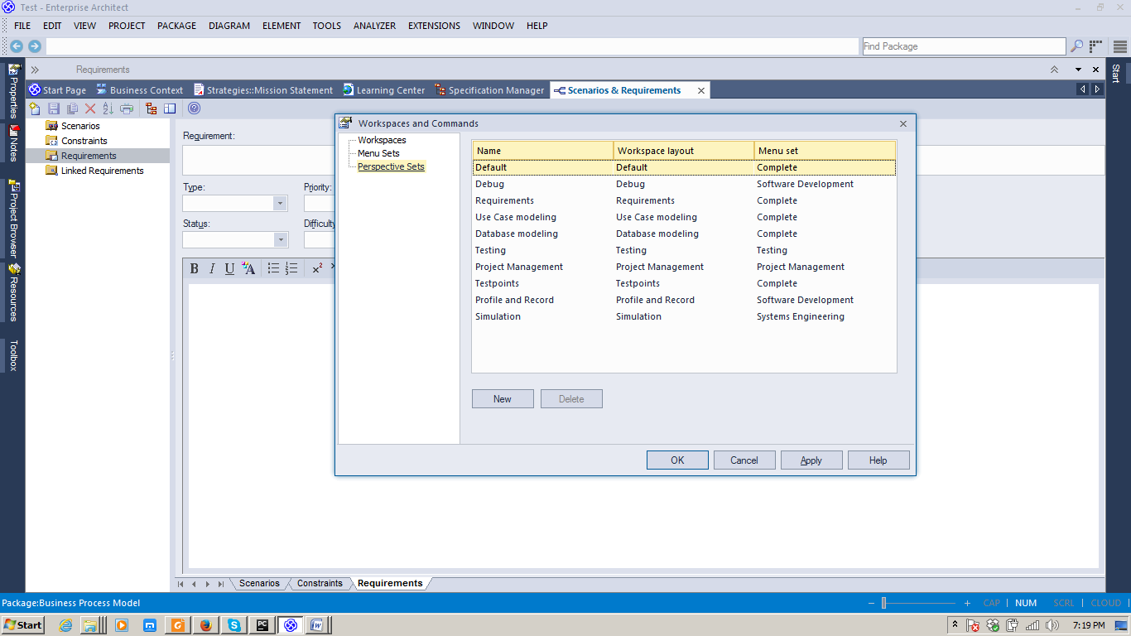

Record BA context(scenarios, requirements, constraints, linked requirements etc (Word, Excel, PPT artifacts)); Analyze and identify the type of the requirement (Display, Functional, Testing, Validate, Printing etc)

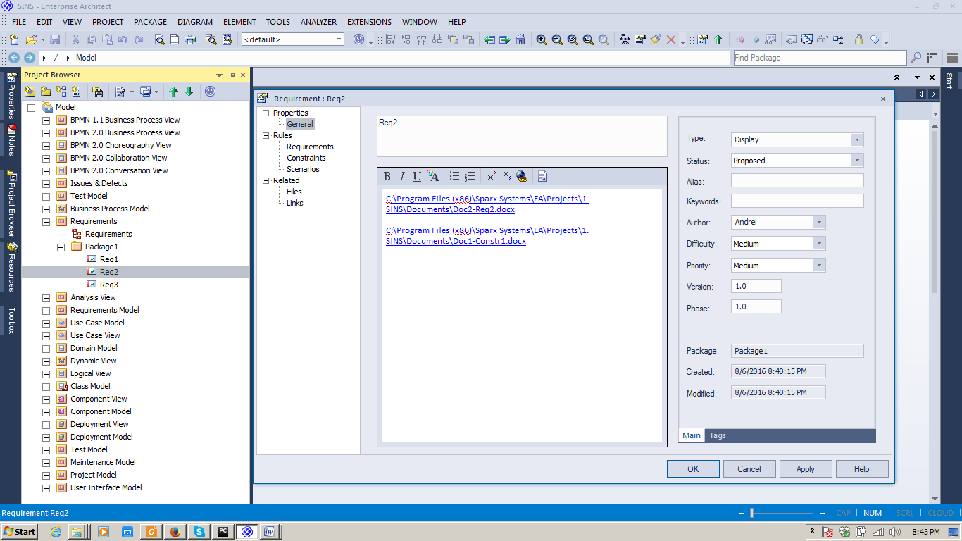

Implement Req2 using linked artifacts to modeling objects (UCs, CDs, SDs etc):

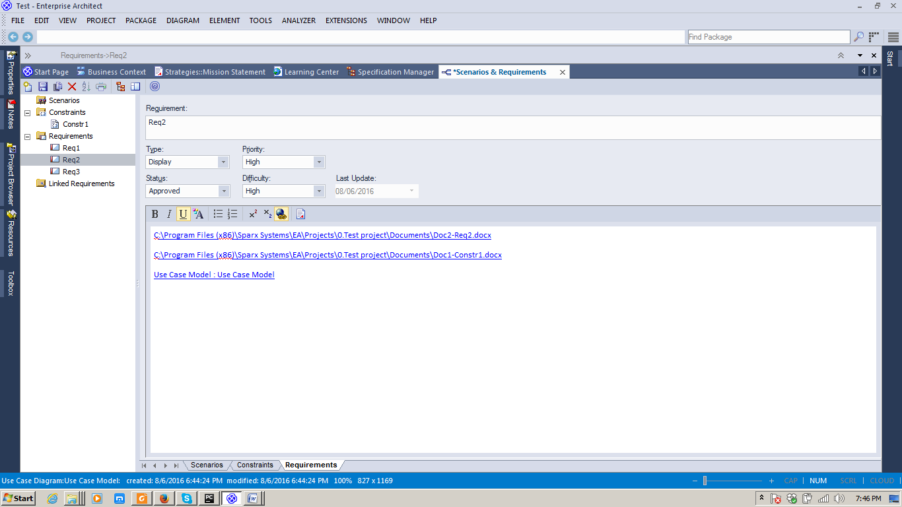

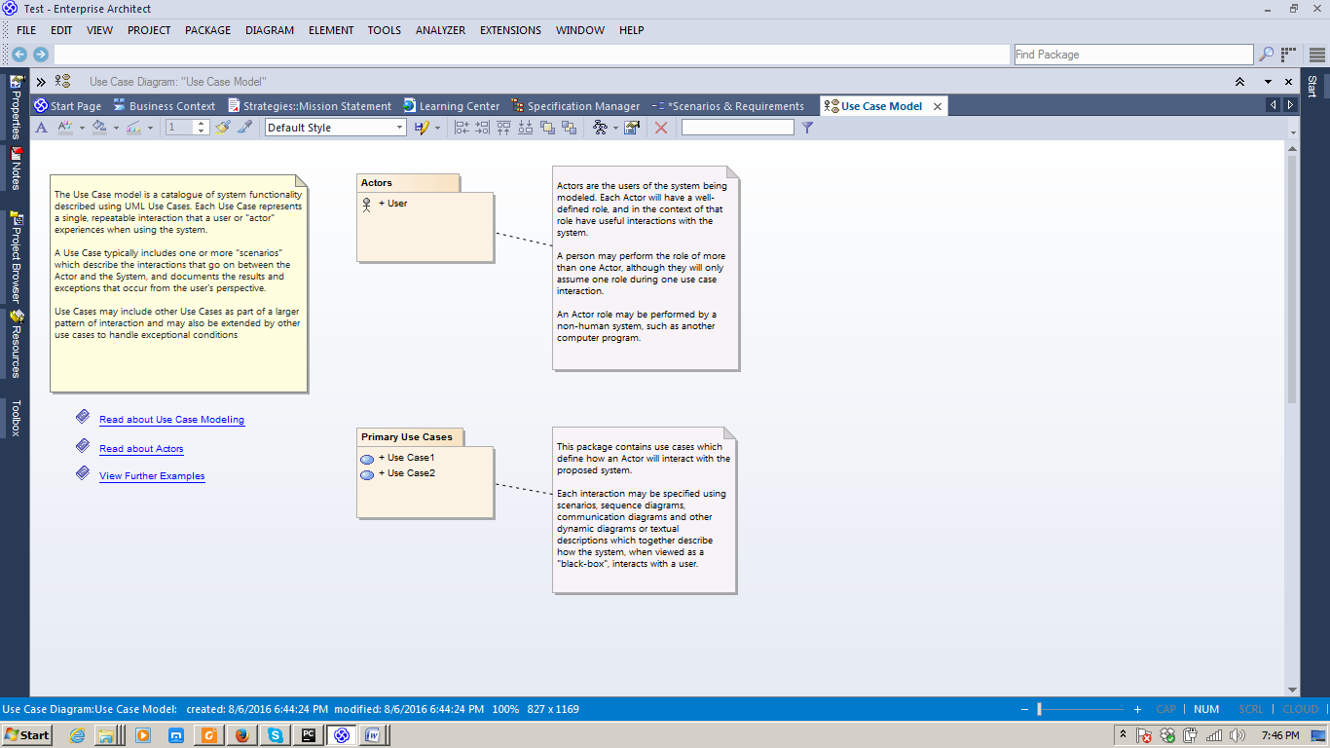

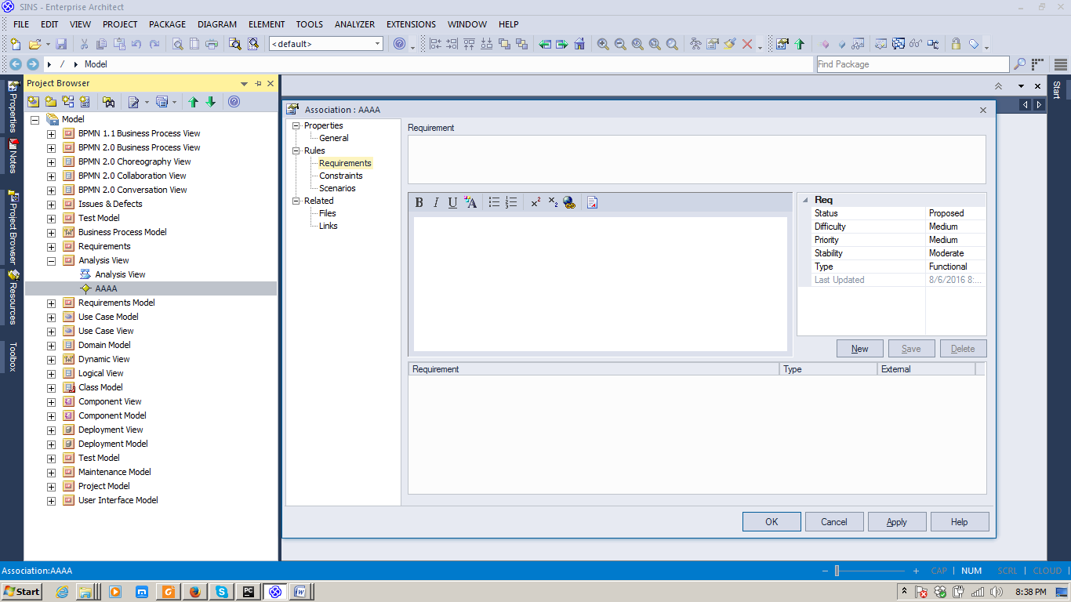

http://www.sparxsystems.com/products/ea/requirements.html

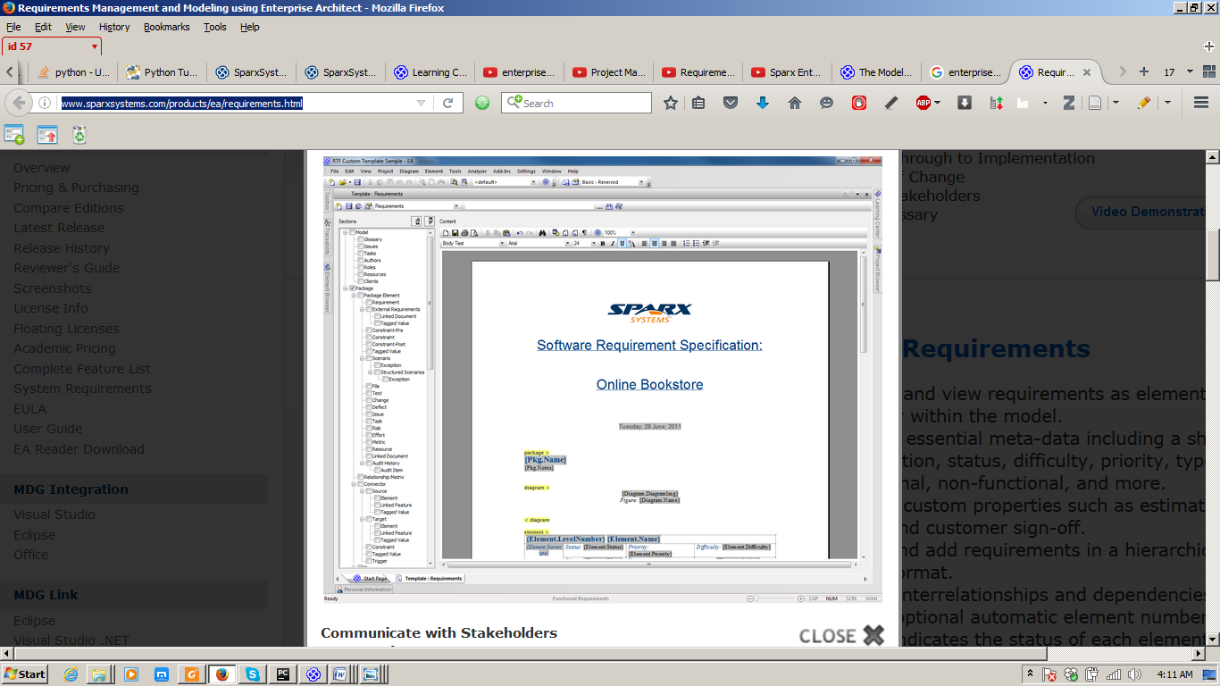

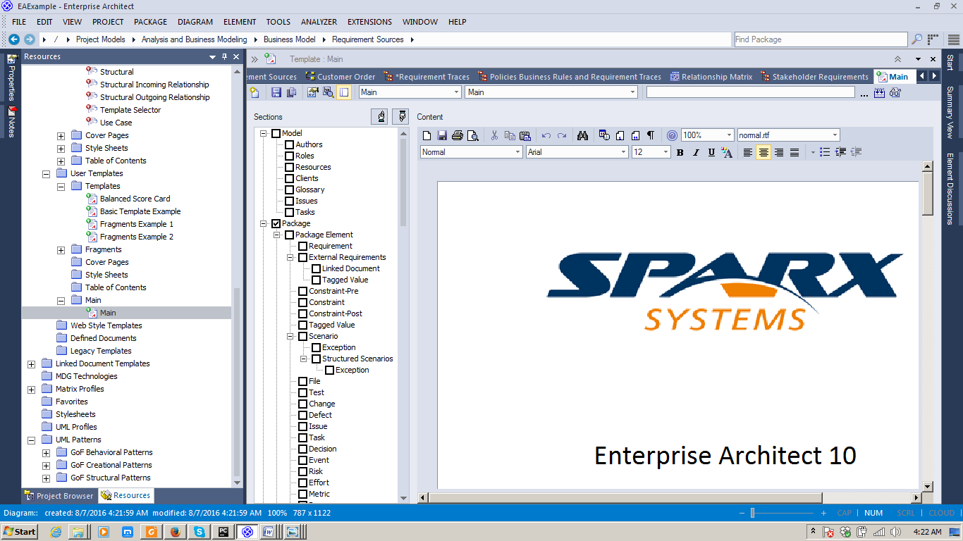

Communicate with Stakeholders=>Use Resources/Templates to document requirements

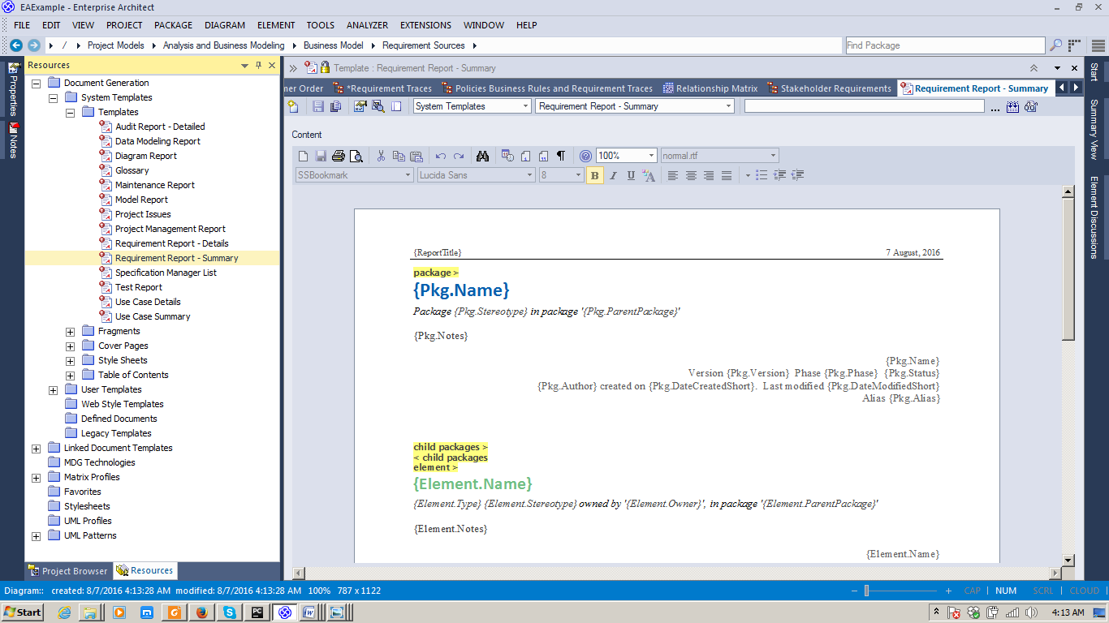

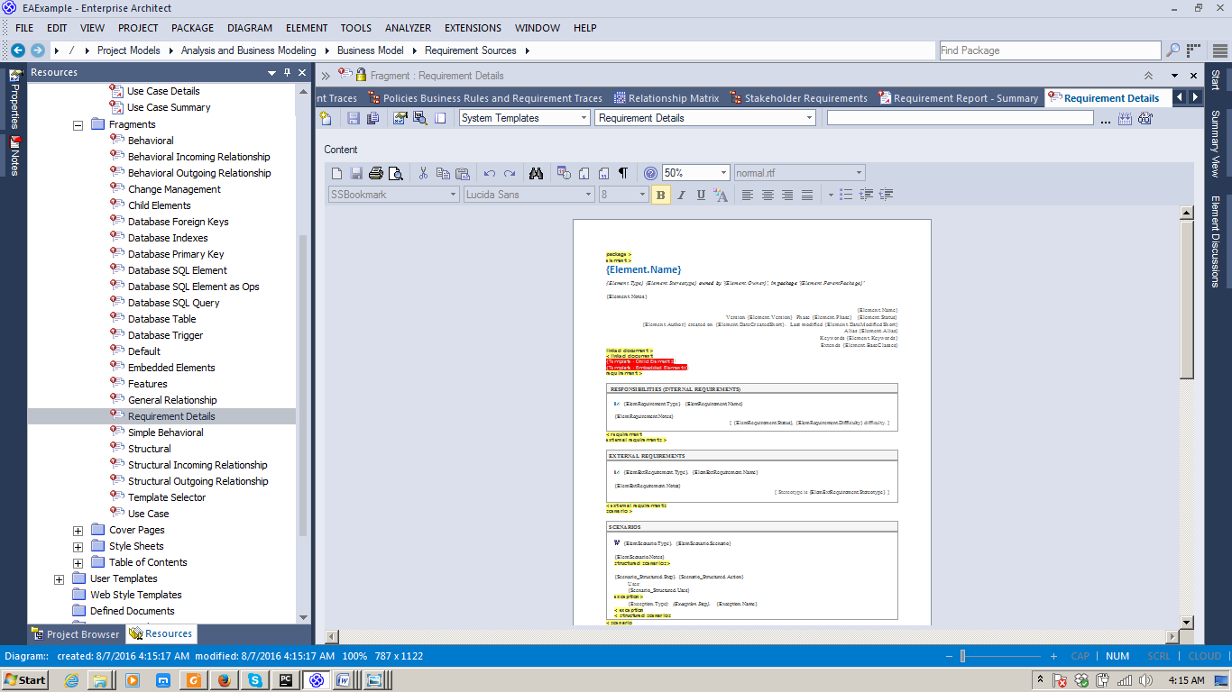

Work straight in the document to add new details, scenarios etc:

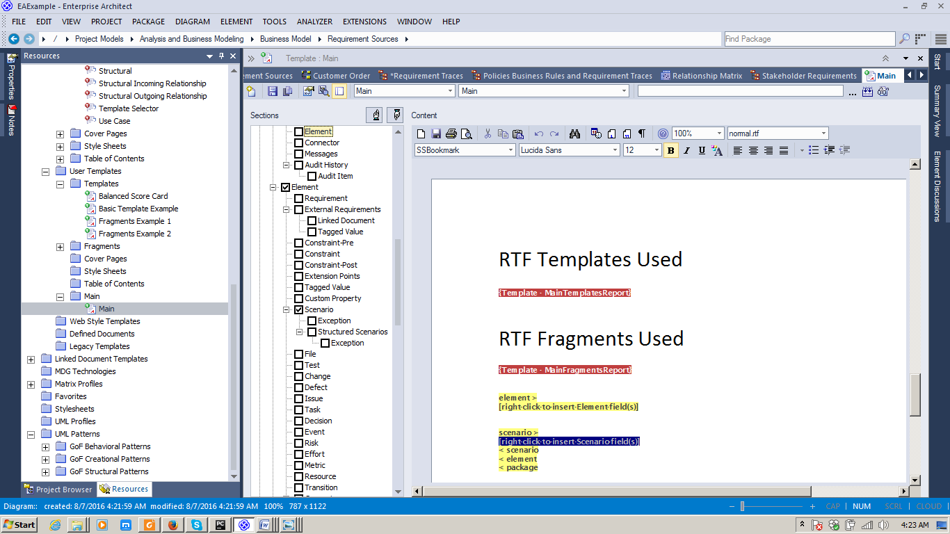

Set relationships between elements (e.g Requirements - Use Cases) directly using Relationship Matrix;

Identify elements in Project Browser with Find + display existing relationships between diagrams and delete the new added one:

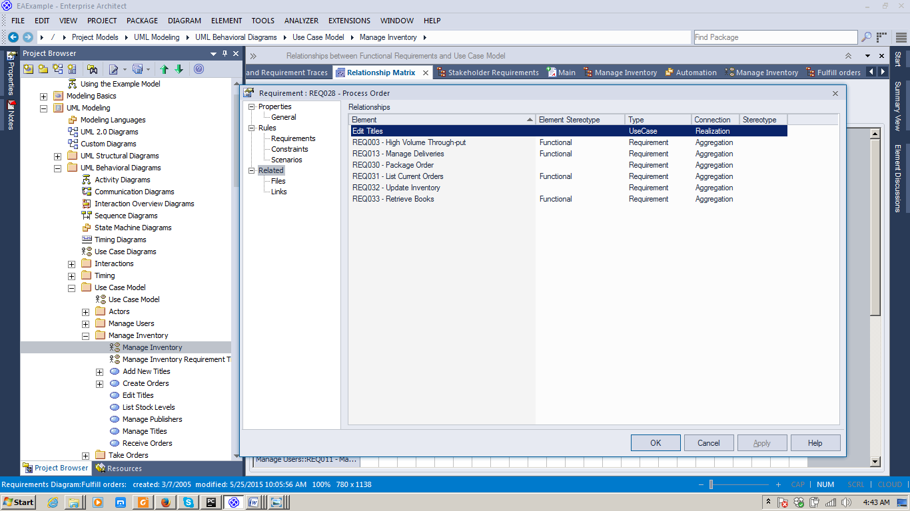

Underlying Requirements for a given Use Case

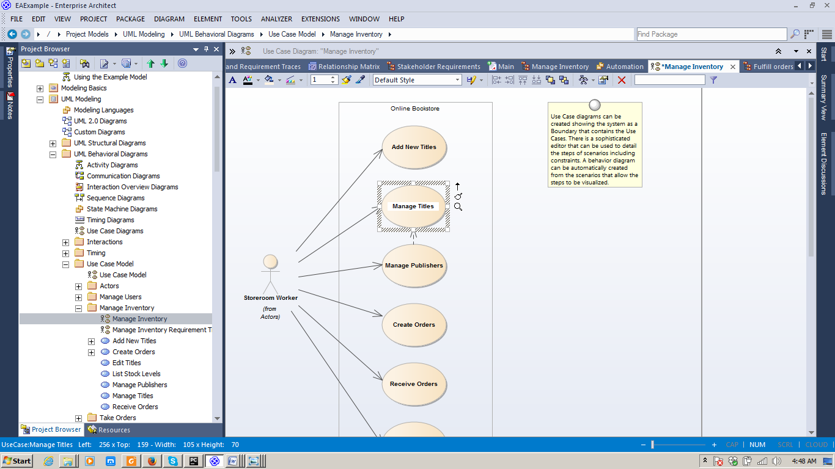

)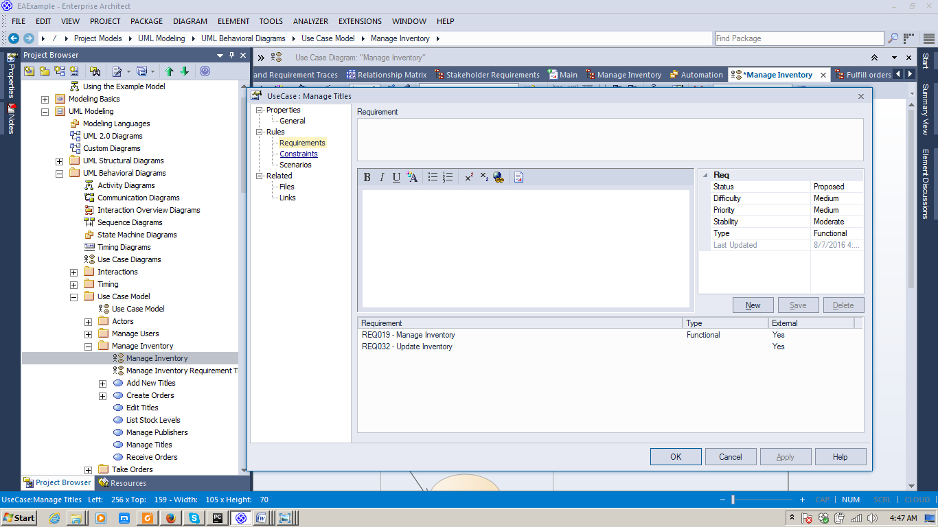

New relationship added between UC(Edit Titles) --Requirement(Req028~) (will be deleted)

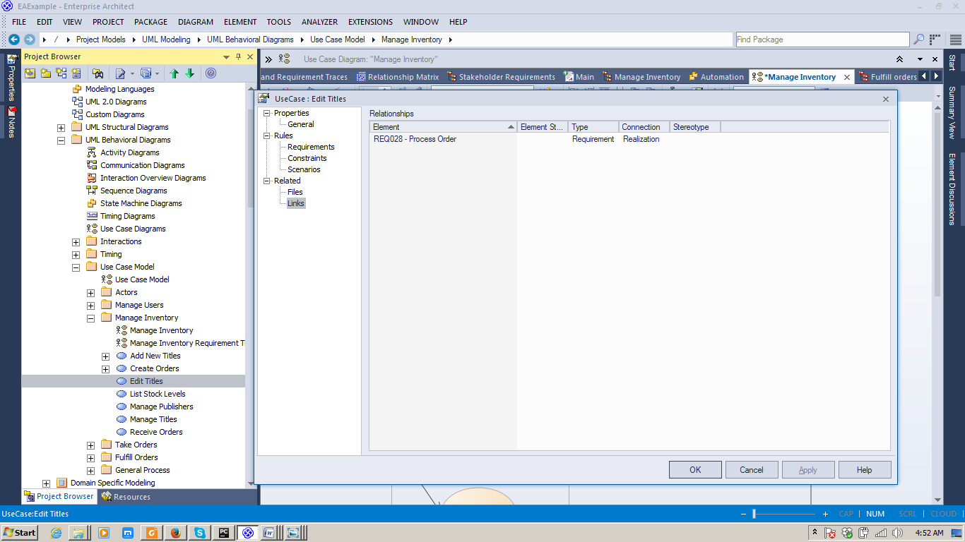

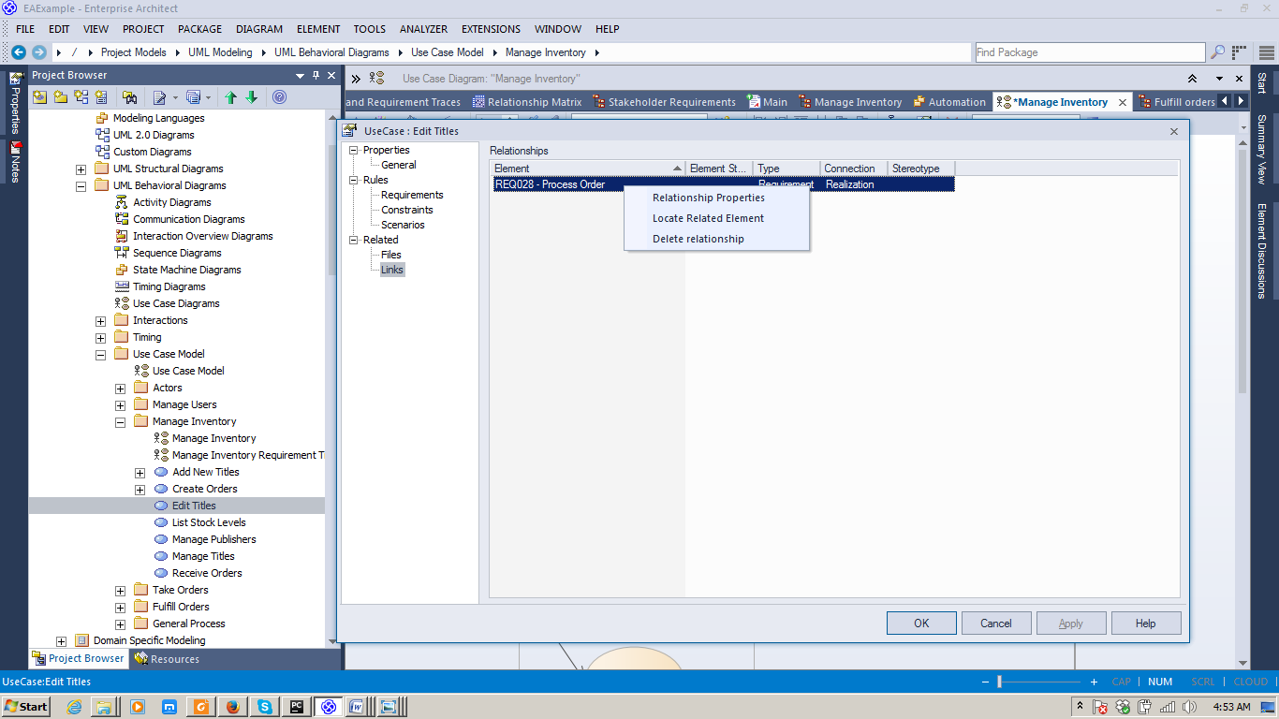

Relationship properties:

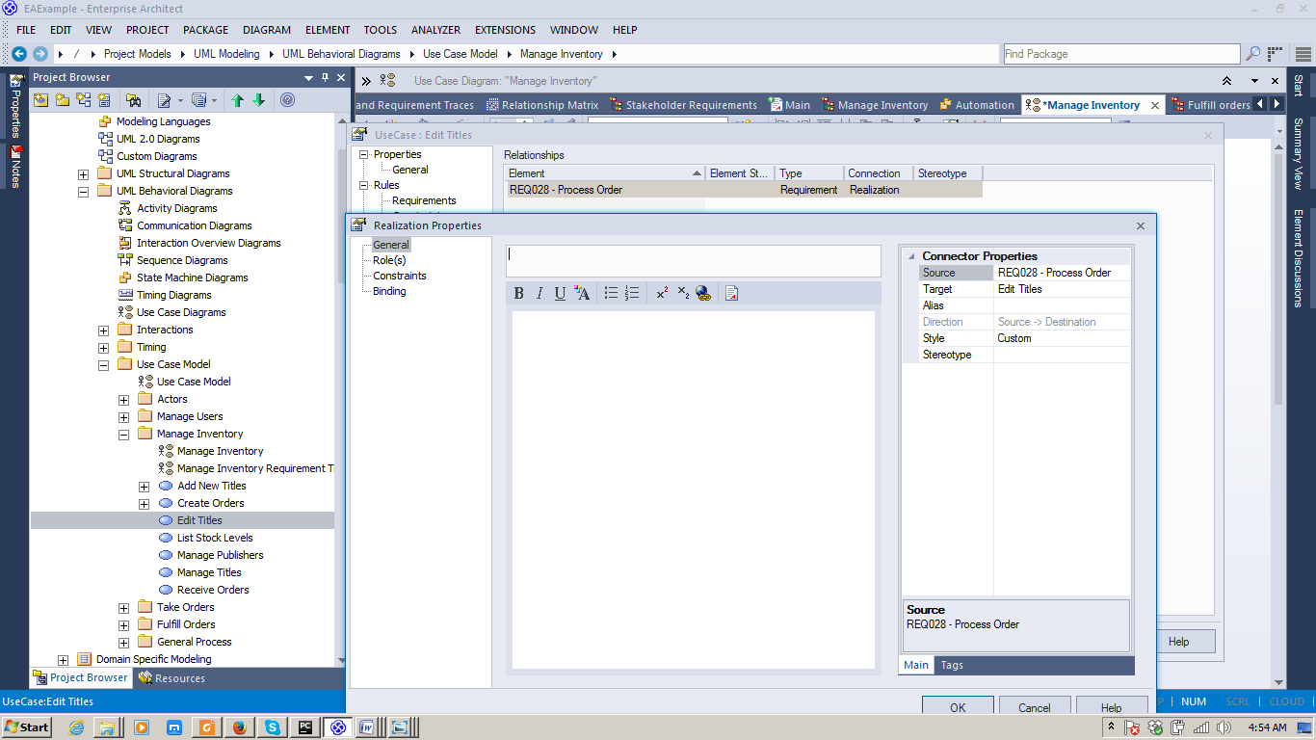

After deletion:

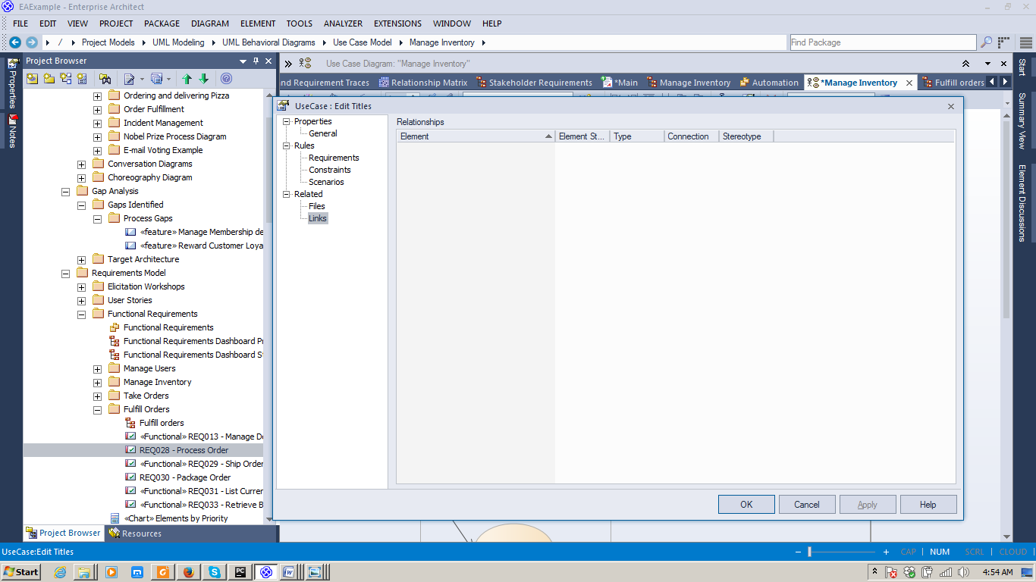

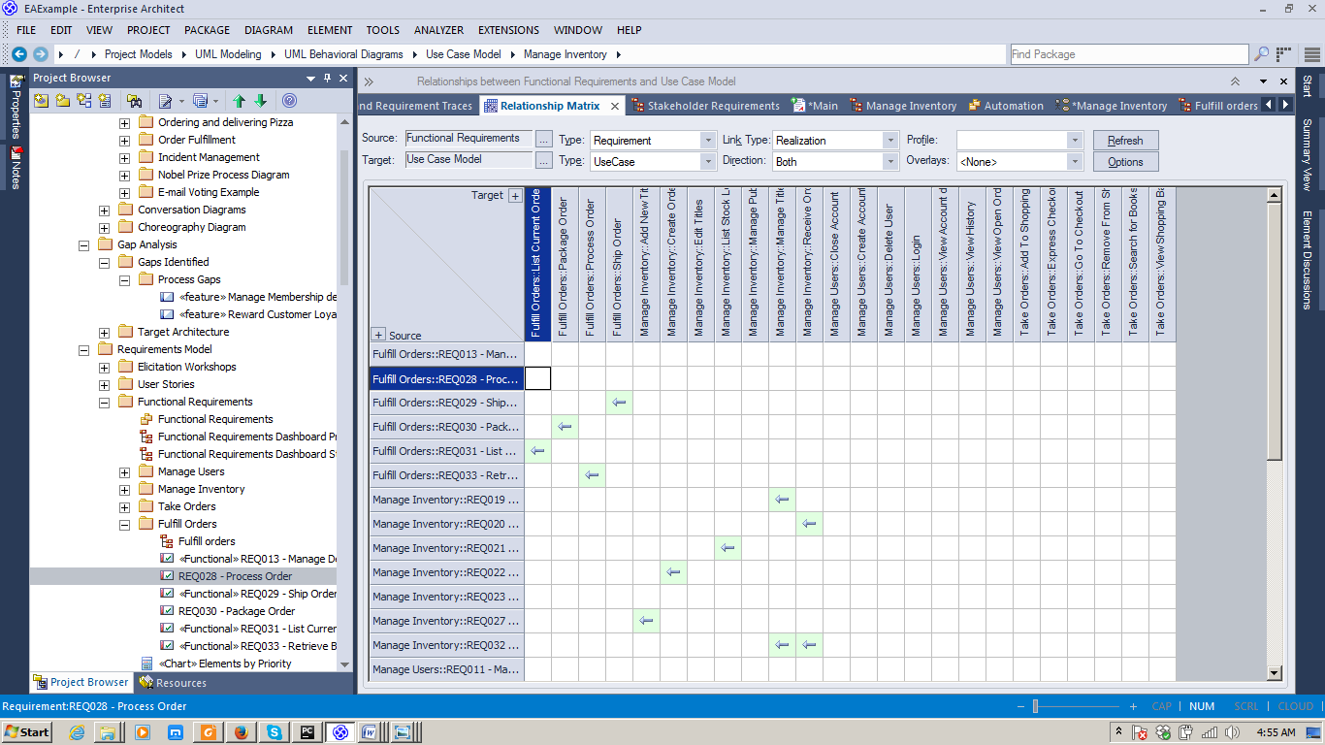

Add multiple objects with the same profile structure (entity, process etc) in a diagram

